Flight Booking Reservation System
Aim
To create a cloud-based Flight Booking Reservation System using Zoho Creator to manage flight details, passenger information, and flight reservations.
Procedure
- Log in to Zoho Creator and create a new application named Flight Booking Reservation System.
- Create a form named Flight Reservation Details.
- Add the following fields:
  - Passenger Name
  - Phone Number
  - Email
  - From
  - To
  - Departure Date
  - Trip Type (One Way / Round Trip)
  - Travel Class (Economy / Business / First Class)
  - Flight Type (Domestic / International)
  - Number of Travelers
- Enter the passenger and flight details.
- Save the records and view the flight reservations online.
Implementation
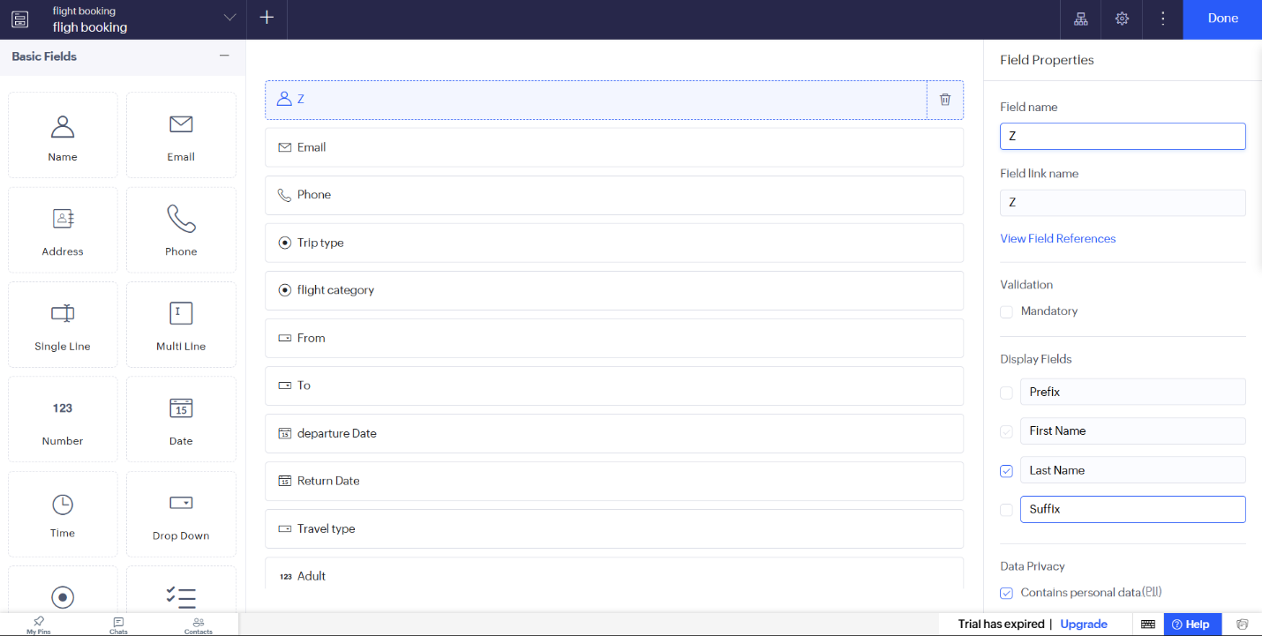

Result
Thus, a cloud-based Flight Booking Reservation System was created successfully using Zoho Creator to manage passenger details and flight reservation information.

